**Multicollinearity and Influence Analysis**

## **1. Introduction**

In statistical modeling and regression analysis, understanding relationships between independent variables is crucial. Two key aspects to consider are **multicollinearity** and **influence analysis**. These factors can significantly impact the accuracy and interpretability of a model.

## **2. Multicollinearity**

### **2.1 Definition**

Multicollinearity occurs when two or more independent variables in a regression model are highly correlated. This can lead to unreliable regression coefficient estimates and affect the model's interpretability.

### **2.2 Effects of Multicollinearity**

* **Inflated Standard Errors**: High correlation between predictors increases the standard errors of regression coefficients.
* **Unstable Coefficients**: Small changes in data can cause large variations in coefficient estimates.
* **Reduced Interpretability**: Difficult to determine the independent effect of each predictor on the dependent variable.

### **2.3 Detecting Multicollinearity**

* **Variance Inflation Factor (VIF)**:
  + Measures how much the variance of a regression coefficient is inflated due to collinearity.
  + A VIF > 10 indicates high multicollinearity.
* **Correlation Matrix**:
  + A high correlation (> 0.8 or 0.9) between independent variables suggests multicollinearity.
* **Eigenvalues and Condition Number**:
  + Small eigenvalues indicate near collinearity, and a condition number above 30 signals severe multicollinearity.

**Example Image: Correlation Matrix Heatmap**

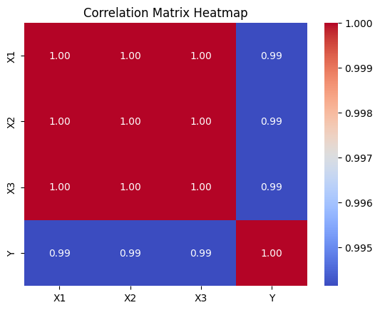

### **2.4 Solutions to Multicollinearity**

* **Remove Highly Correlated Variables**: Drop one of the correlated predictors.
* **Feature Engineering**: Combine correlated variables into a single variable.
* **Principal Component Analysis (PCA)**: Transform variables into uncorrelated components.
* **Ridge Regression**: Adds a penalty term to reduce the impact of correlated variables.

## **3. Influence Analysis**

### **3.1 Definition**

Influence analysis identifies observations in a dataset that have a disproportionate impact on the regression model. Such observations can be outliers or leverage points that skew the results.

### **3.2 Methods for Influence Analysis**

* **Cook’s Distance**:
  + Measures how much the regression coefficients would change if a particular observation is removed.
  + A value greater than 0.5 indicates a moderate influence, and >1 indicates a strong influence.
* **Leverage (Hat Matrix Diagonal Values)**:
  + Identifies influential data points based on their leverage in the regression model.
  + High leverage points can distort model estimates.
* **DFFITS and DFBetas**:
  + DFFITS: Measures the impact of each observation on the predicted value.
  + DFBetas: Measures the change in regression coefficients when a specific observation is removed.

**Example Image: Cook’s Distance Plot**

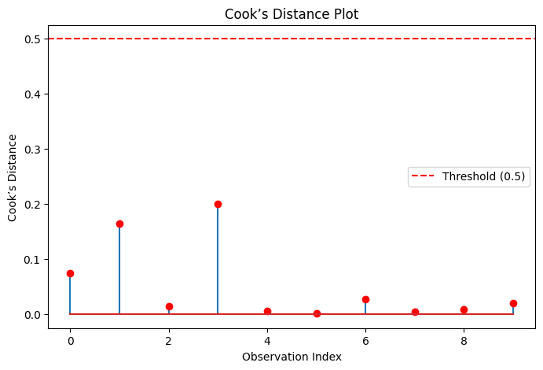

### **3.3 Handling Influential Points**

* **Investigate the Data**: Check for data entry errors or anomalies.
* **Remove or Transform Outliers**: Use techniques like log transformation, winsorization, or robust regression.
* **Use Robust Regression Models**: Models like Huber Regression or Quantile Regression reduce the effect of influential points.

## **4. Conclusion**

Understanding **multicollinearity** and **influence analysis** is essential for building robust regression models. By detecting and addressing these issues, we can improve model reliability, interpretability, and predictive power.

Including visual aids such as **correlation matrices** and **Cook’s Distance plots** further enhances comprehension and helps in identifying problematic data points effectively.